SHS Robotics Website Update

The website has not been updated in two years and design/content needs to be refreshed. Recommend the following sections (**heading labels below**) with the suggested content below……………

# Home:

Team Logo’s

Team Picture

Document our 2018 district entries – Granite State & UNH (venue pictures?)

Section to update latest Entropy news from Entropy (something we refresh with frequency)?

Team calendar (meetings that are updated, community events, competitions, etc.)?

# About Us:

The Souhegan High School proudly sponsors the FIRST Robotics Team 138 - “Entropy”, founded in 1996. Entropy is group of students interested in the fields of business, engineering, math, and science. With the help of adult mentors, the team designs & builds a robot to compete in the FIRST Robotics Competition. Our team starts meeting in early October and wraps up the year with a team awards banquet in May.

Team Awards:

| *Year* | *FIRST Event* | *FIRST Awards* |
| --- | --- | --- |
| 2002 | UTC New England Regional | Leadership in Controls Award |
| 2004 | Granite State Regional | Granite State Regional Finalist |
| 2005 | Granite State Regional | Granite State Regional Finalist  Radio Shack Innovation in Control Award  Website Excellence Award |
| 2006 | Granite State Regional | Delphi Driving Tomorrow's Technology Award |
| 2007 | Granite State Regional | AutoDesk Visualization Award |
| 2008 | Granite State Regional | AutoDesk Visualization Award  Website Excellence Award |
| 2009 | Granite State Regional | AutoDesk Visualization Award |
| 2011 | North Carolina Regional | North Carolina Regional Finalist |
| 2014 | Granite State District  NE Championship Qualifier | Granite State District Winner  Industrial Design by General Motors |
| 2015 | Granite State District  UNH District  NE Championship Qualifier  World Championship Qualifier | Granite State District Finalist  Industrial Design by General Motors  UNH Judges Award |
| 2016 | Granite State District  NE Championship Qualifier | Granite State Judges Award |

Contact Us:

Robotics team email - roboticsteam138@gmail.com

Lead mentor email (Brian Walters) – bfwalters@comcast.net

Souhegan High School contact (Pam Paul) email – ppaul@sprise.com

# FIRST:

Include FIRST & FRC logos

FIRST FRC home page - <http://www.firstinspires.org/robotics/frc>

NE FIRST - https://nefirst.org/

What WINS in FIRST?

•Working as a team to achieve a common goal

•Collaborating on ideas to solve a complex problem

•Decompose a complex activity into a manageable set of tasks

•Learning to operate in a constrained environment practicing time management skills

•Behaving in the spirit of “Gracious Professionalism” and “Coopertition”

What WINS FIRST Competitions?

•Proficient drive team – practice, practice, practice!

•Sound game strategy augmented with informed scouting feedback

•Competitive robot design – do one thing very well!

•Good alliance partners – luck of the draw!

Define what is “Gracious Professionalism” and “Coopertition” (on the current website)

Current Game Animation:

2017 Steamworks Animation (replace with 2018 PowerUp animation when released)

Current Game Description:

2017 Steamworks Description (replace with 2018 PowerUp description when released)

# Sponsorships:

Include links to our corporate sponsors & team mentor picture



[](http://www.rockwellautomation.com/) 

[](http://www.rapidsheetmetal.com/index.aspx)   [](http://www.datron.com/index.php) [](http://poiriertool.com/)

***John Albert Welding Services***

***BB Molding Company***

Team mentor group picture

# Past Robots:

Include brief game description with past robot pictures & links to key competition videos

2011 LogoMotion Robot – North Carolina Regional Finalist

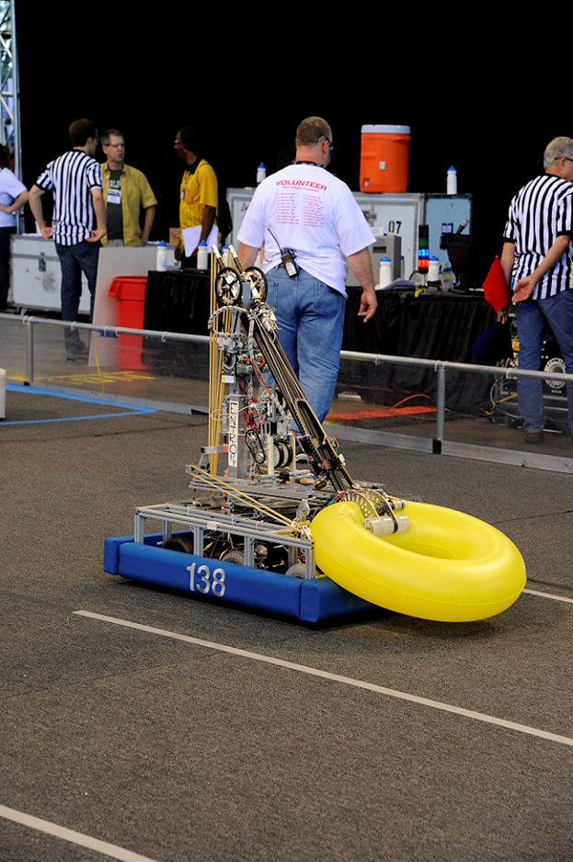

2012 Aim High Robot

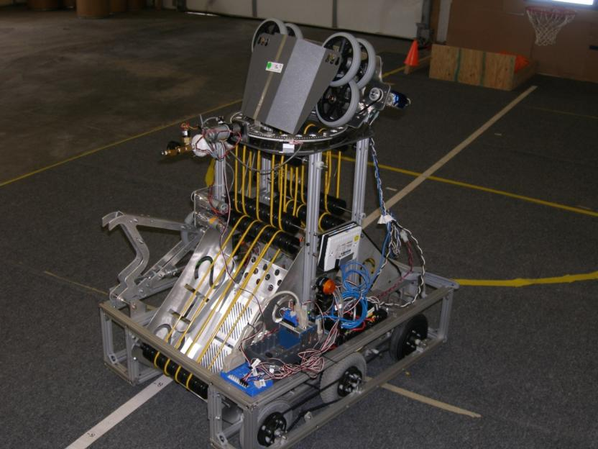

2013 Robot

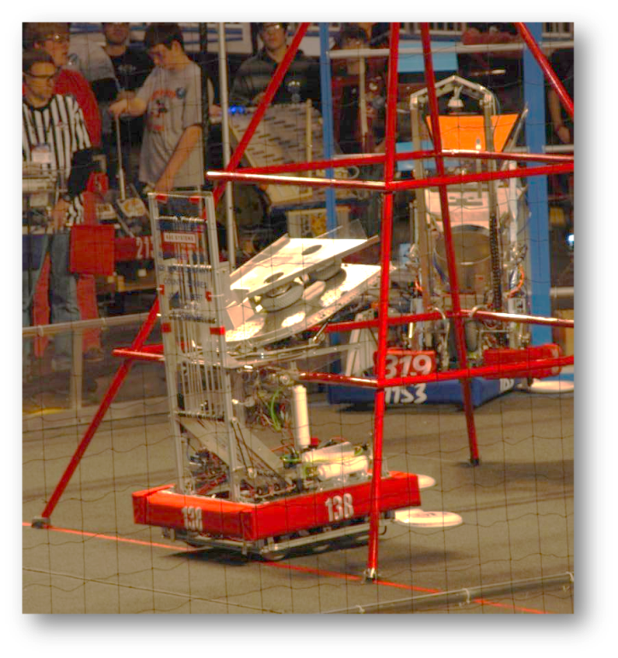

2014 Robot –Granite State District Champion; NE Championship Qualifier

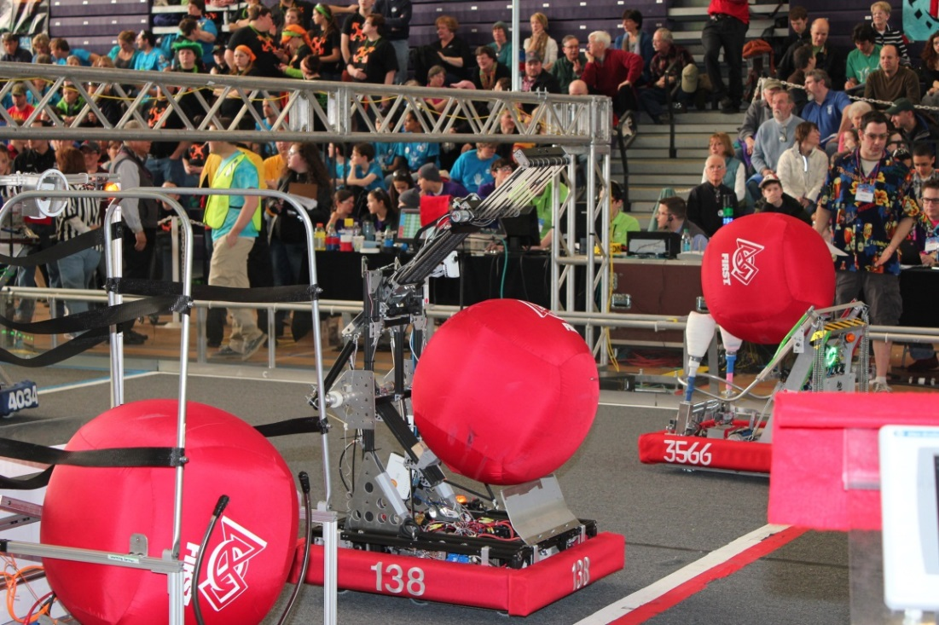

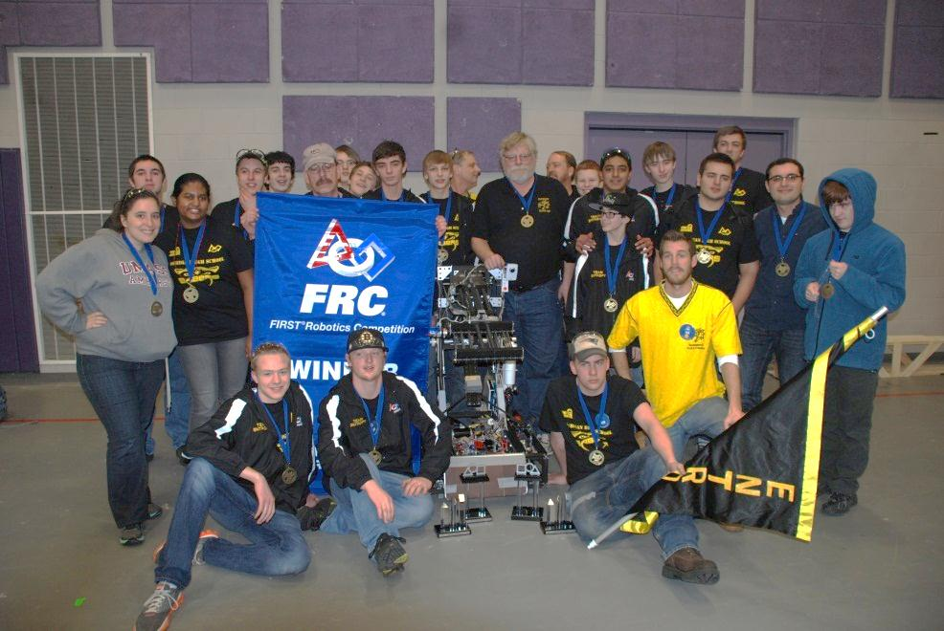

Link to competition video – GSD

2015 Recycle Rush Robot –Granite State District Finalist; NE Championship 5th Place; World Qualifier

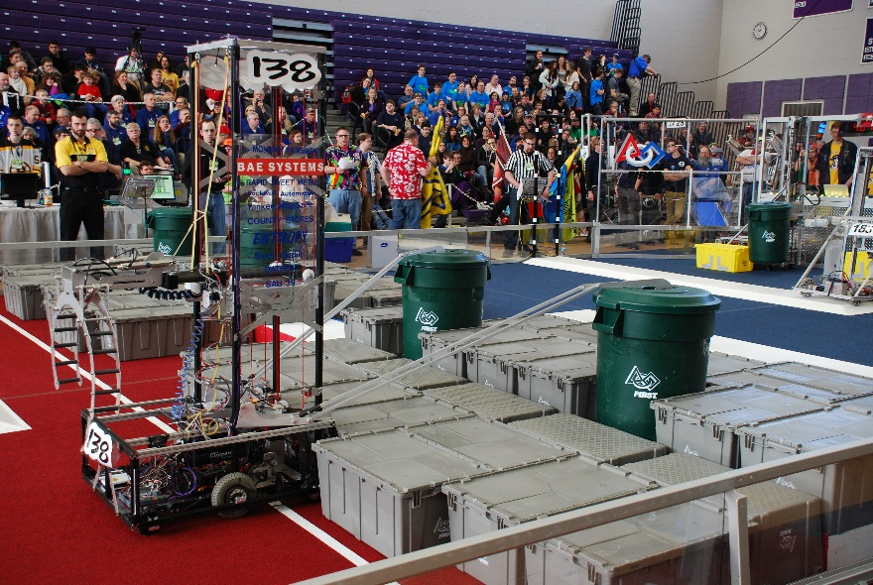

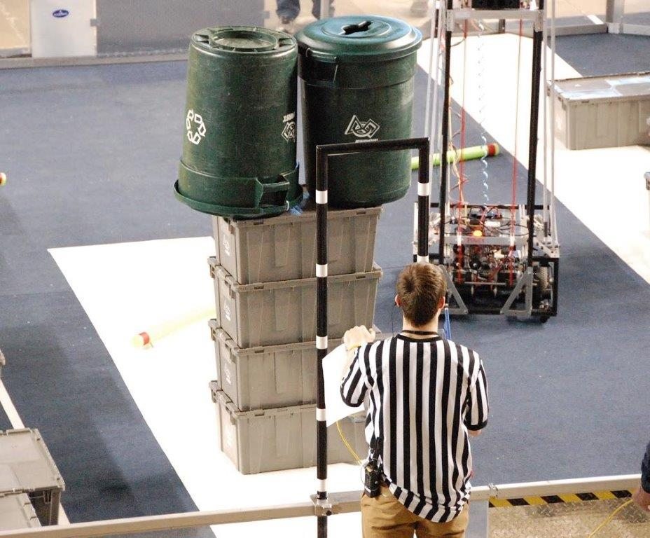Double Capper!!!

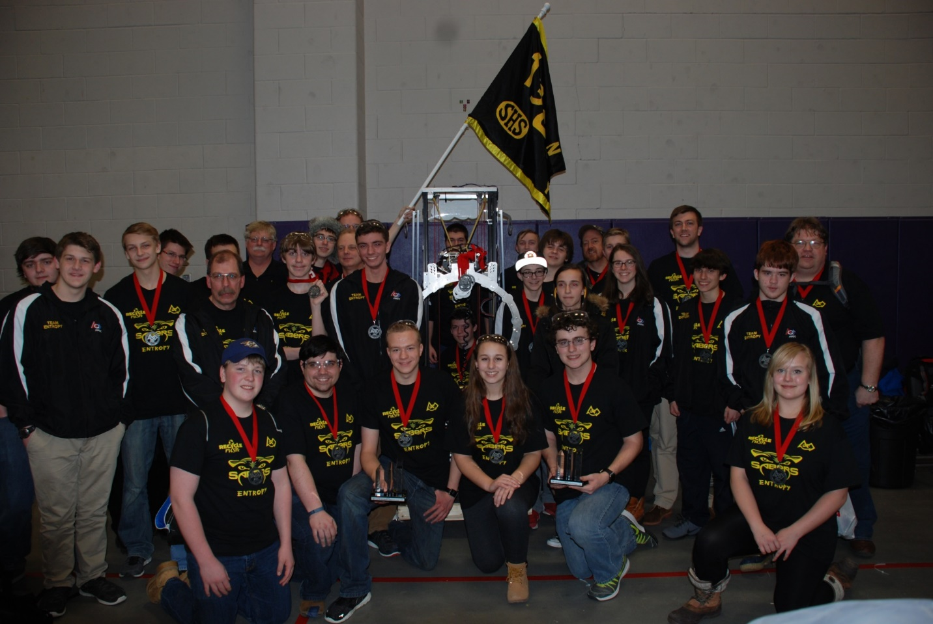

Link to UNH competition video - Double Capper (www.youtube.com/watch?v=aS1c3nN_4gM)

Link to NEC competition video - Autonomous Tug-of-War (www.youtube.com/watch?v=yLlSAqHkxZU)

Link to NEC competition video – Elimination Quarterfinals (www.youtube.com/watch?v=GJVnFWa6Ggk)

2016 Stronghold Robot – NE Championship Qualifier

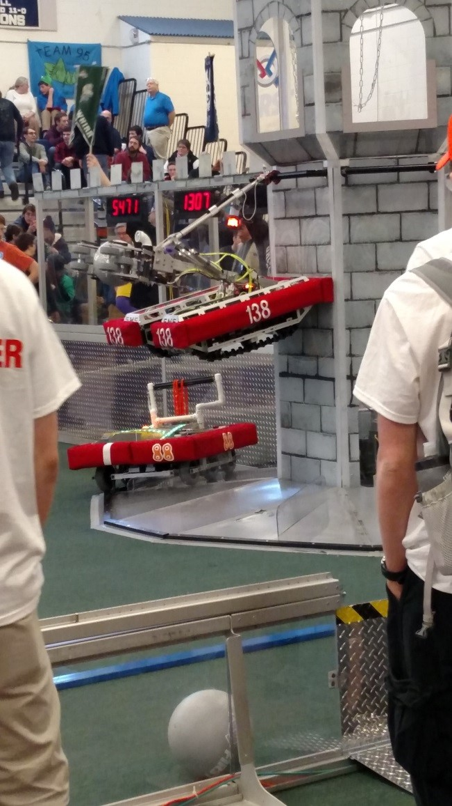

2017 Steamworks Robot

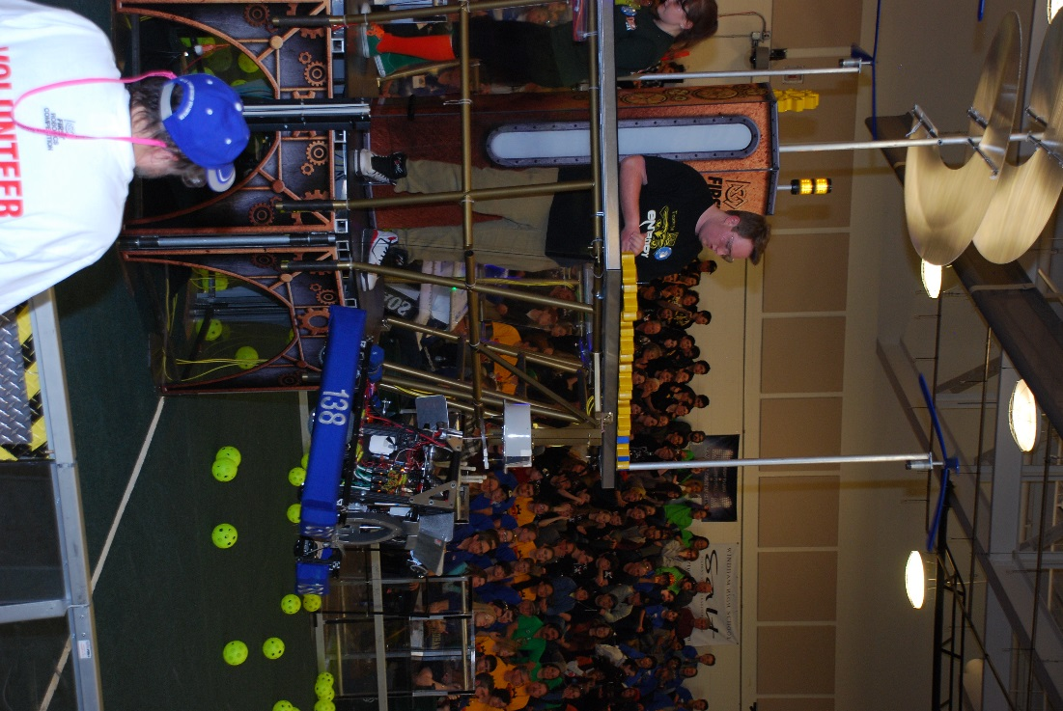

# Fundraising – 2018 Comedy Night:

Date, Location, Time, Ticket Price, & Where to Buy Tickets

Event description

List of Comedians (pictures?)

# Resources:

FIRST Resource Library - [www.firstinspires.org/resource-library](http://www.firstinspires.org/resource-library)

Chief Delphi Forums - [www.chiefdelphi.com/forums/portal.php](http://www.chiefdelphi.com/forums/portal.php)

Blue Alliance – [www.bluealliance.com](http://www.bluealliance.com)

FIRST Control System - wpilib.screenstepslive.com/s/currentCS

WPI Library Project - github.com/wpilibsuite

WPI Library Documentation - [users.wpi.edu/~bamiller/WPILib/WPILib.pdf](https://users.wpi.edu/~bamiller/WPILib/WPILib.pdf)

Getting Started with Java - wpilib.screenstepslive.com/s/currentCS/m/java

Vision Processing - wpilib.screenstepslive.com/s/currentCS/m/vision

VexPro Robotics Examples - www.vexrobotics.com/vexpro/examples-guides/?ref=tile

Team Tutorials:

CyberKnight References - [www.mhthompson.com/KingsRobotics/FRC/links.php](http://www.mhthompson.com/KingsRobotics/FRC/links.php)

Team 254 Resources - [www.team254.com/resources/](http://www.team254.com/resources/)

Team 610 Design Tutorials - [www.team610.com/wp-content/uploads/2014/03/Design-TutorialsRev10.pdf](http://www.team610.com/wp-content/uploads/2014/03/Design-TutorialsRev10.pdf)

Team 1114 Design Tutorials - [www.simbotics.org/resources/robot-design](http://www.simbotics.org/resources/robot-design)

Team 1678 Design References - [www.citruscircuits.org/robot-design.html](http://www.citruscircuits.org/robot-design.html)

# Community Engagement:

Document our support & donation to standup rookie teams in Idaho (talk to Bill).

Document our community service demos - Amherst July 4th Parade, Deland Memorial Library demo, BAE Systems Employee BBQ demo, Amherst Lions Car Show Demo, Amherst Science Fair Exhibit, Amherst Fire & Ice Demo

Town of Amherst July 4th Parade

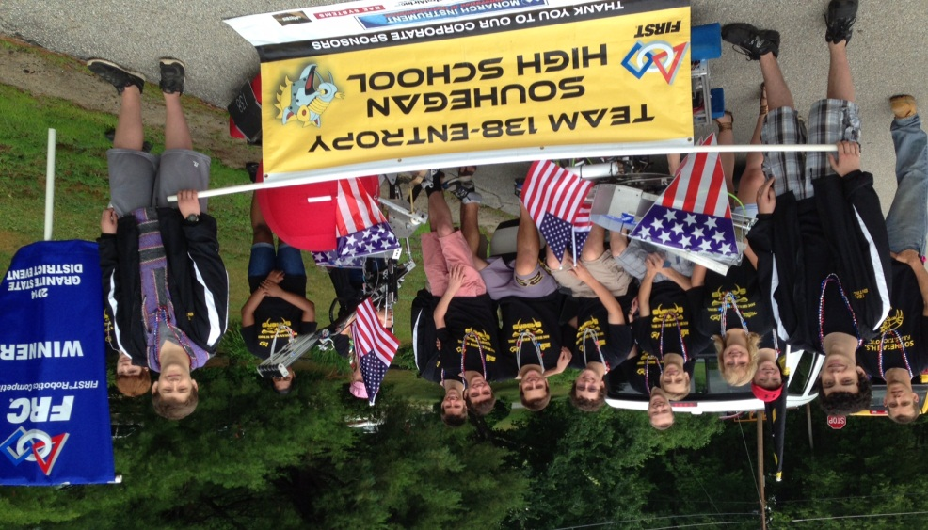

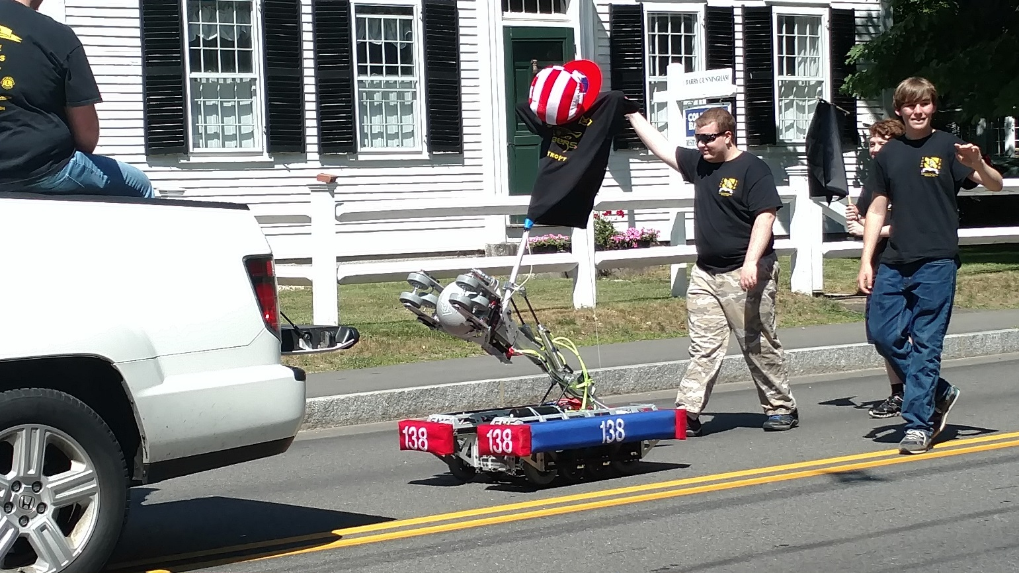

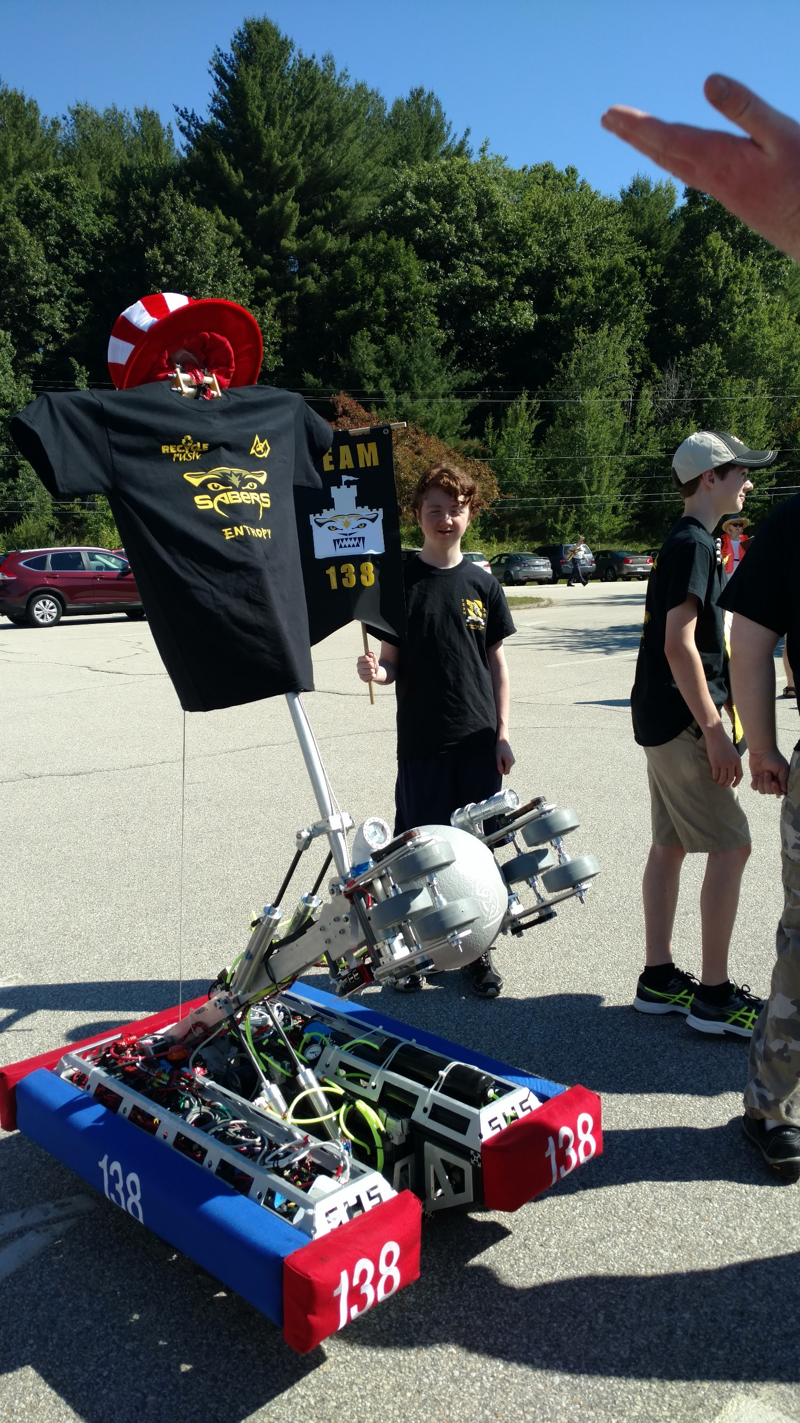

Amherst Lions “Fire and Ice” Demo promoting FIRST & SHS Robotics Team

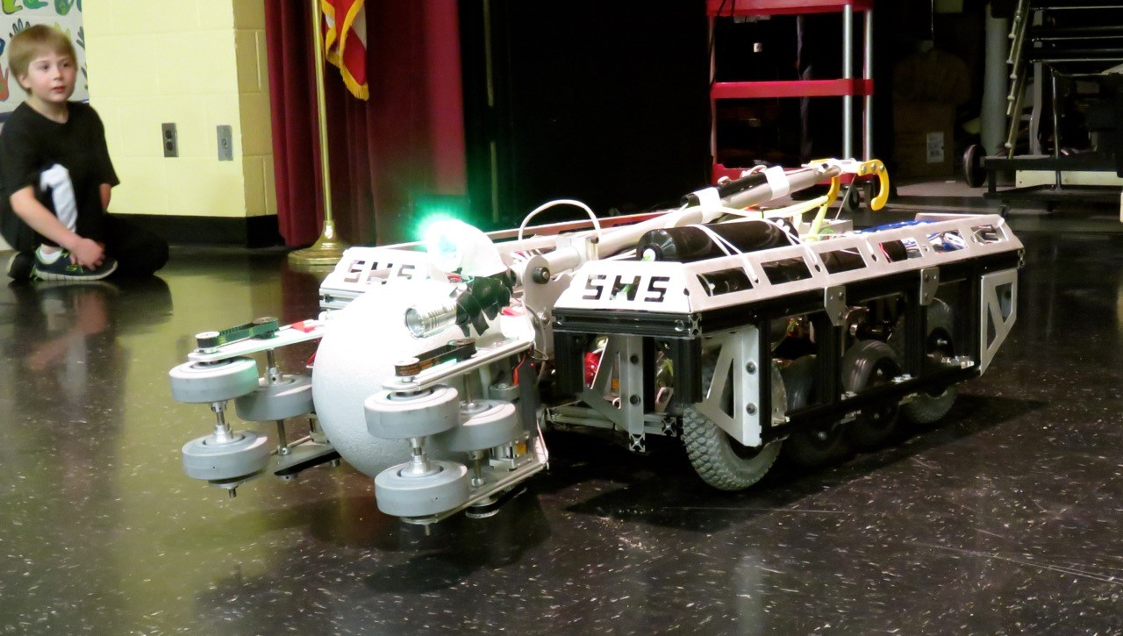

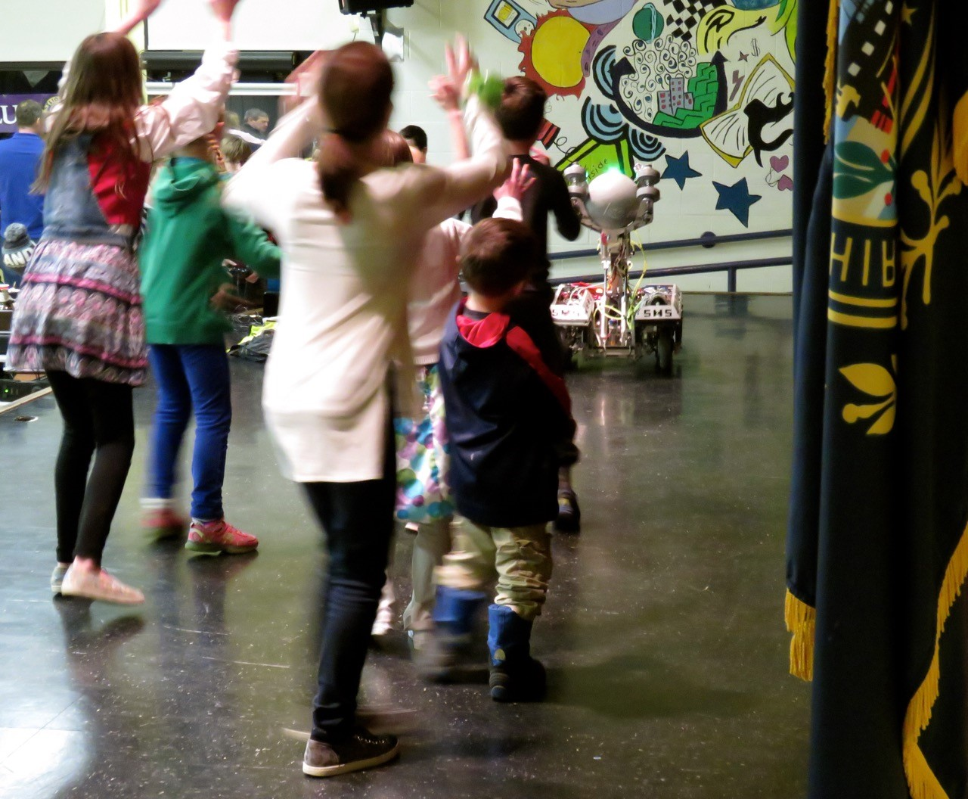

BAE Systems Summer Employee BBQ – Robot Demo

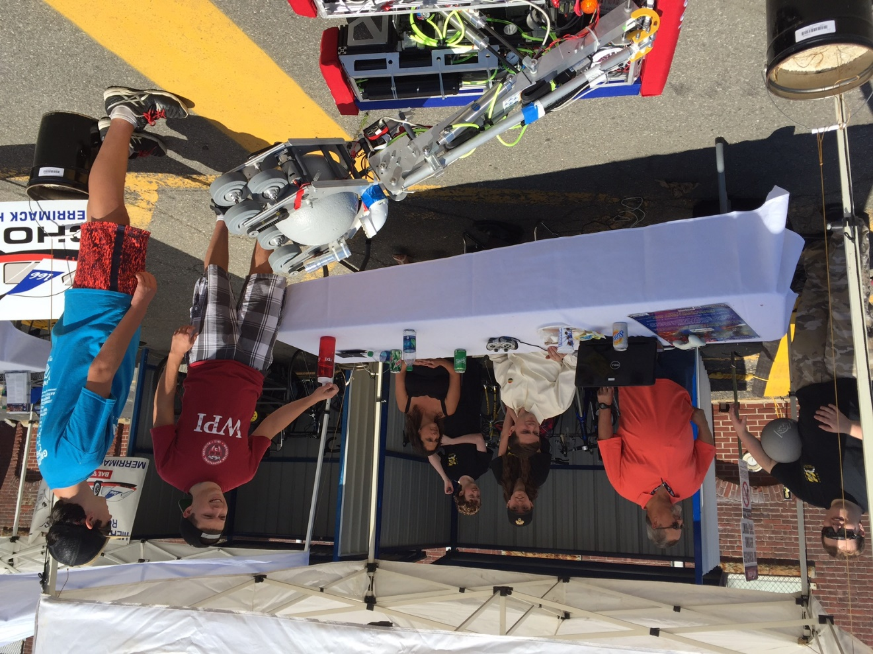

Team sharing FIRST experiences with NH Senator Kelly Ayotte

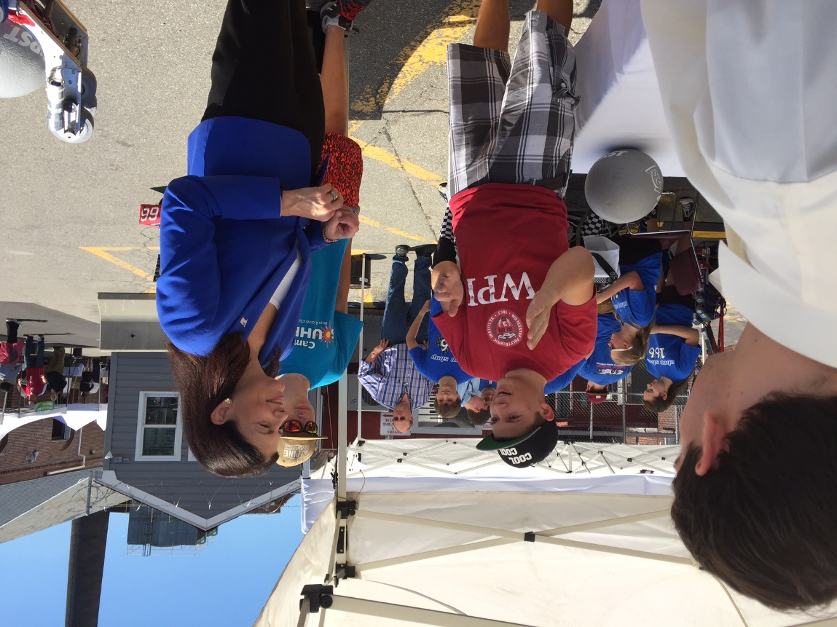

Amherst Lions Car Show – Robot Demo

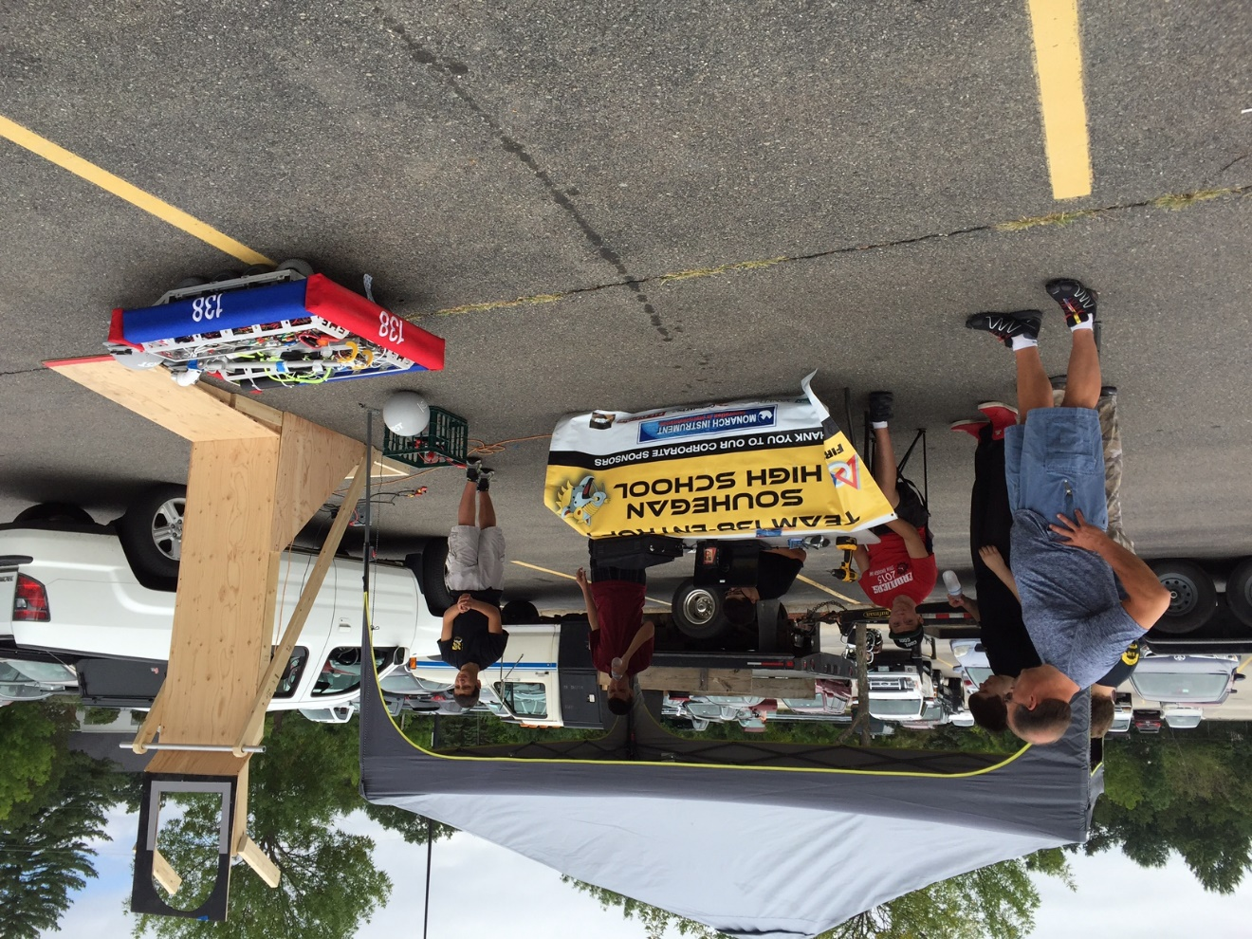

Recruiting future FIRST participants!

